**Computer Networks Laboratory**

**Assignment 6**

Name: Anirban Das Class: BCSE-III  Roll: 001910501077  Group: A3

**Problem Statement:**

Use Cisco Packet Tracer software to do the following experiments.

**OVERVIEW:**

Cisco Packet Tracer is one of the most useful visual simulation programs for networking certifications. With this tool, students are able to experiment with network behavior. As such, they’re able to ask a wide range of questions and explore different scenarios for better results. Since Cisco Packet Tracer is an important part of the Networking Academy, it provides students with an extensive learning experience. Additionally, it offers several visualization, simulation, assessment, collaboration, and authoring capabilities to facilitate hassle-free learning and teaching of complex IT concepts.

**SYSTEM DETAILS:**

OS: 64-bit Windows 10

CPT Version: 8. 0 . 1

**QUESTIONS:**

1. **Connect two hosts back-to-back with a cross over cable. Assign IP addresses, and see whether they are able to ping each other.**

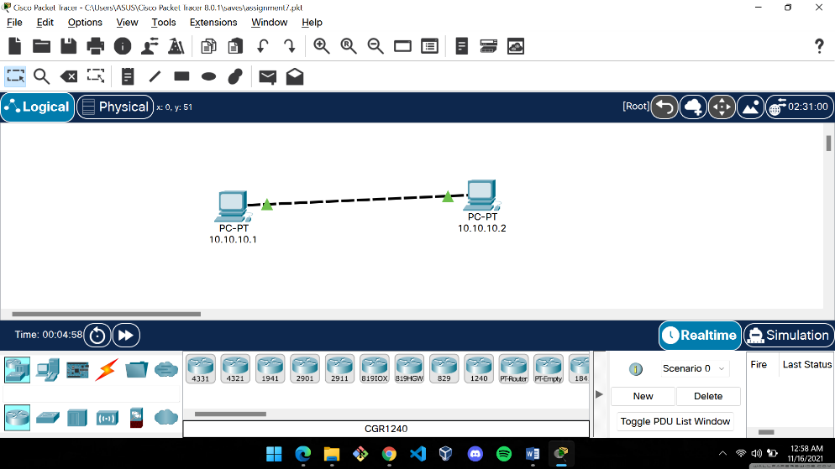

Two hosts were made and connected with a crossover cable.

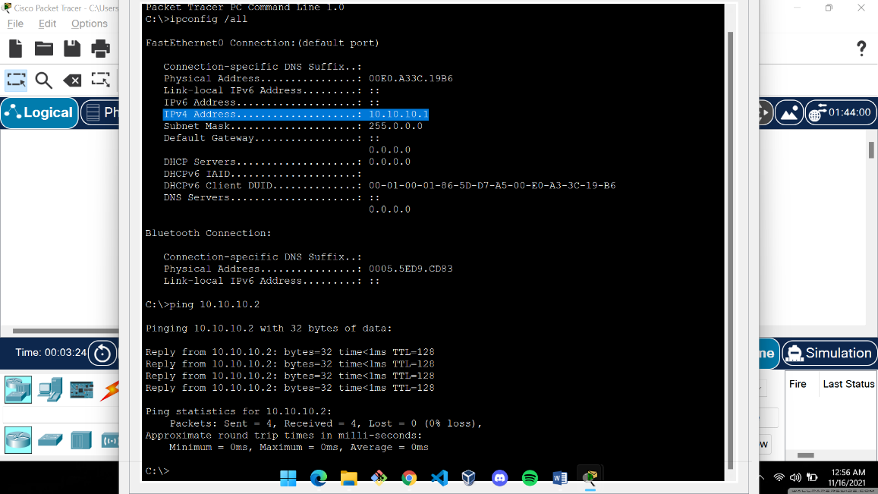 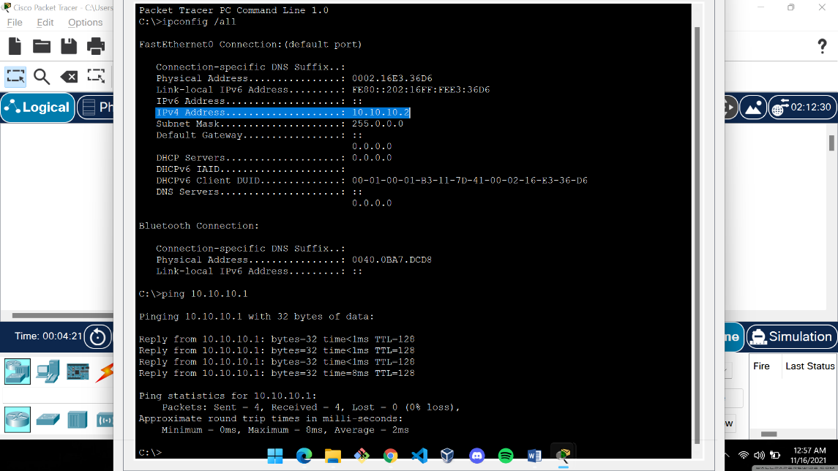

The IP addresses assigned to them were x and y.

Communication was established as shown by the “ping” command.

1. **Create a LAN (named LAN-A) with 3 hosts using a hub. Ping each pair of nodes.**

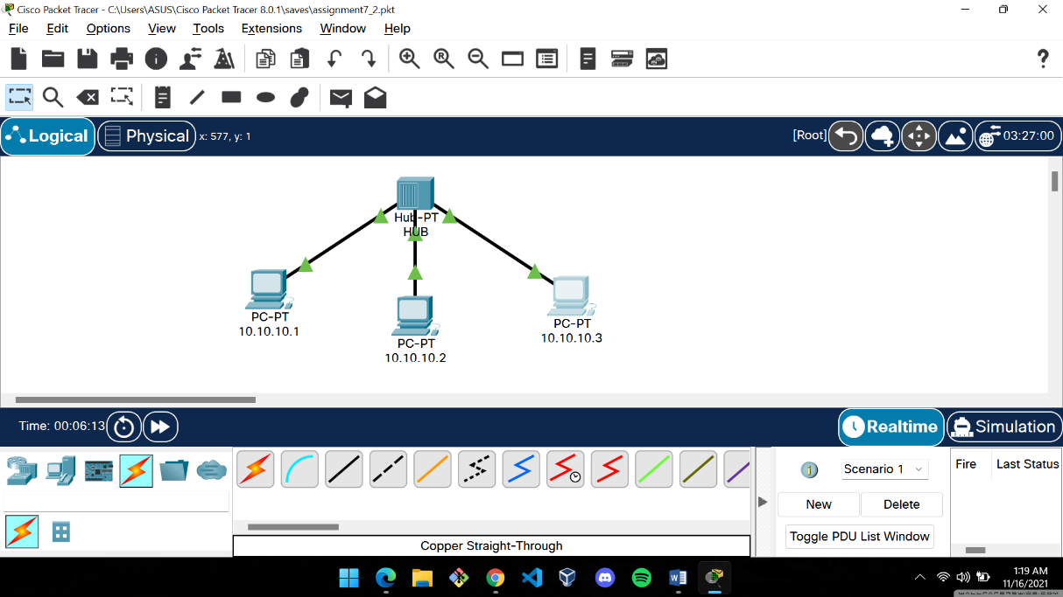

LAN-A was created using a hub and three hosts connected to it using straight through cable.

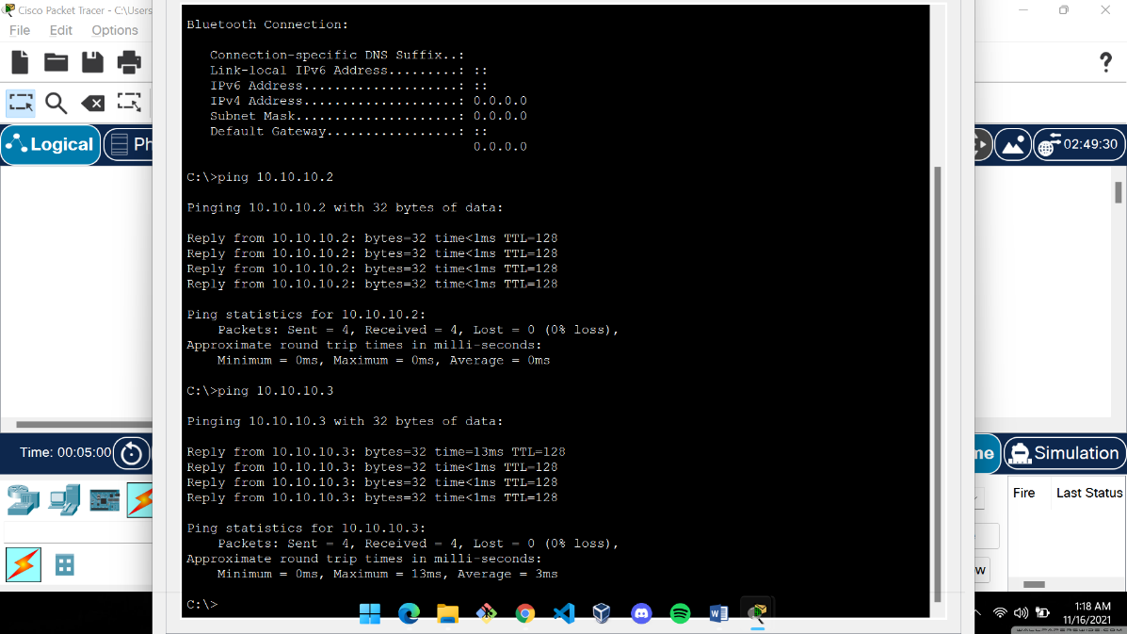 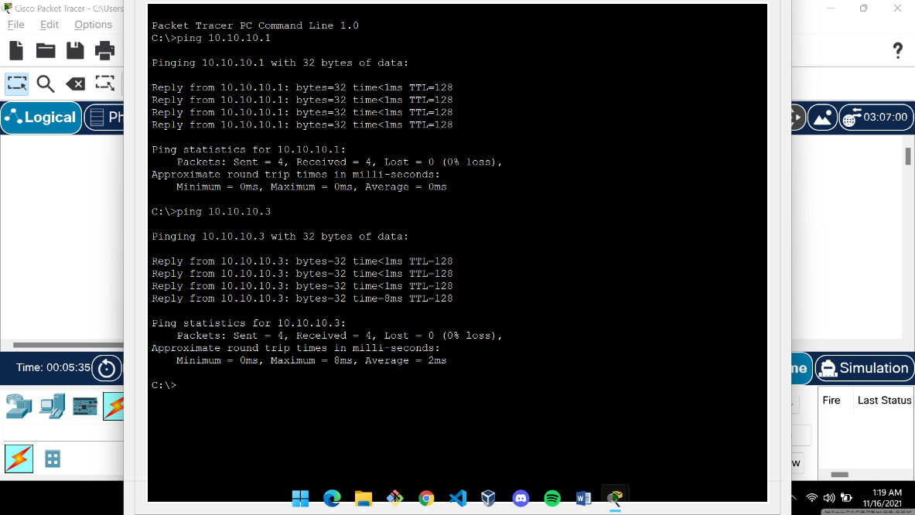

Transmisson from HOST 1 Transmisson from HOST 2

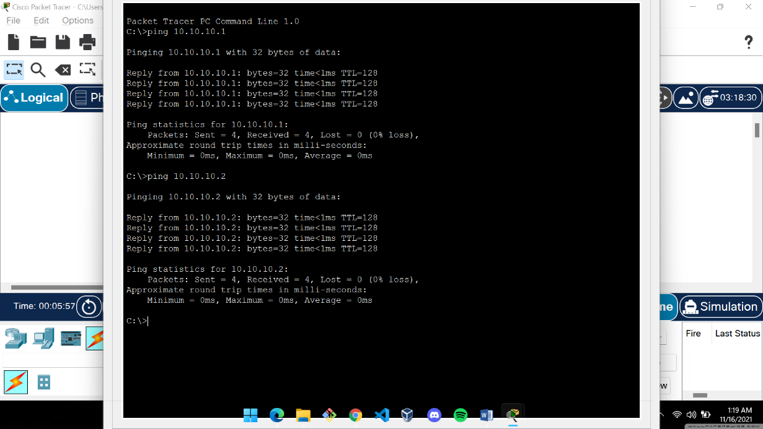

Transmisson from HOST 3

1. **Create a LAN (named LAN-B) with 3 hosts using a switch. Record contents of the ARP Table of end hosts and the MAC Forwarding Table of the switch. Ping each pair of nodes. Now record the contents of the ARP Table of end hosts and the MAC Forwarding Table of the switch again.**

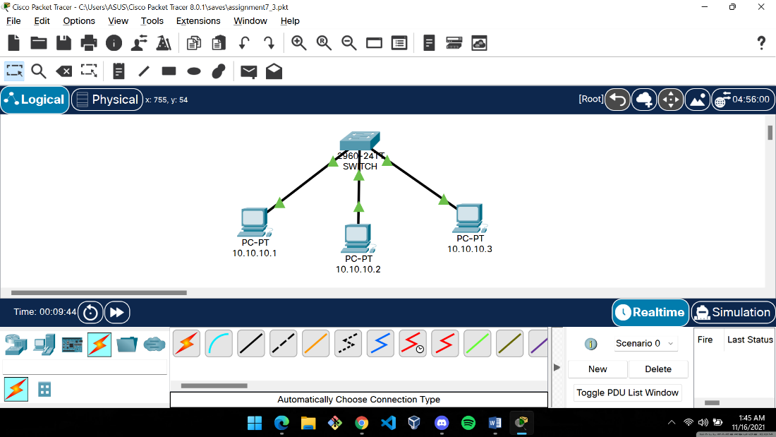

LAN-B was created using a switch (Cisco 2960) and three hosts were connected to it.

Initially (before doing any ping):

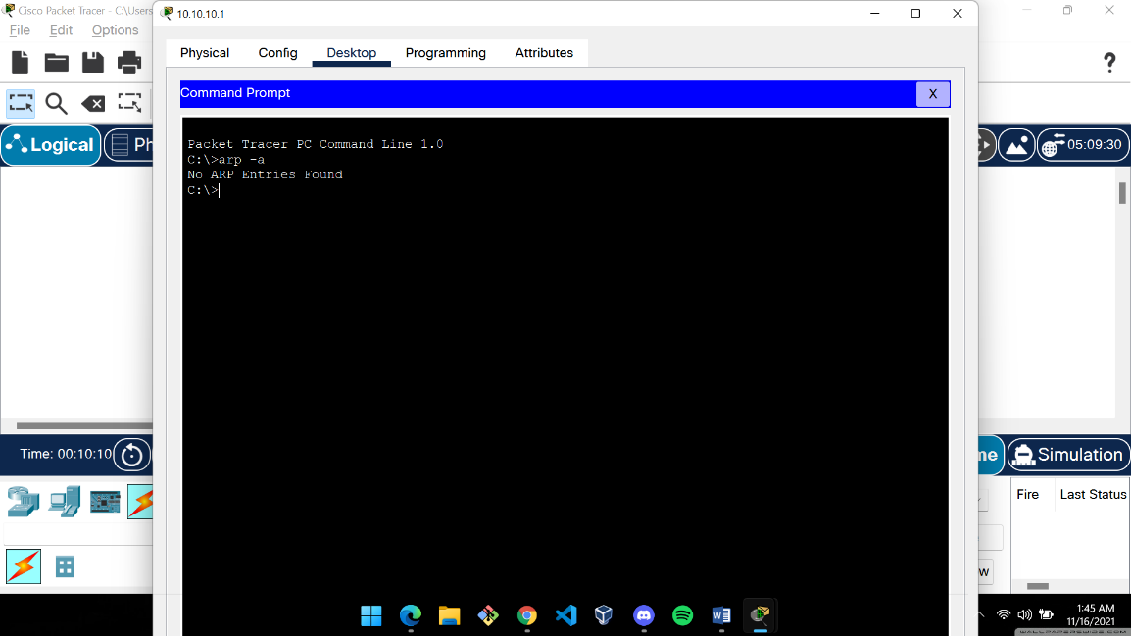

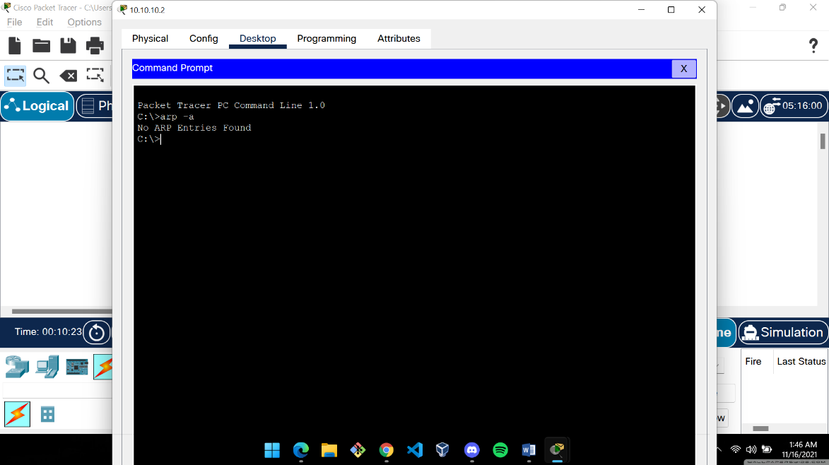

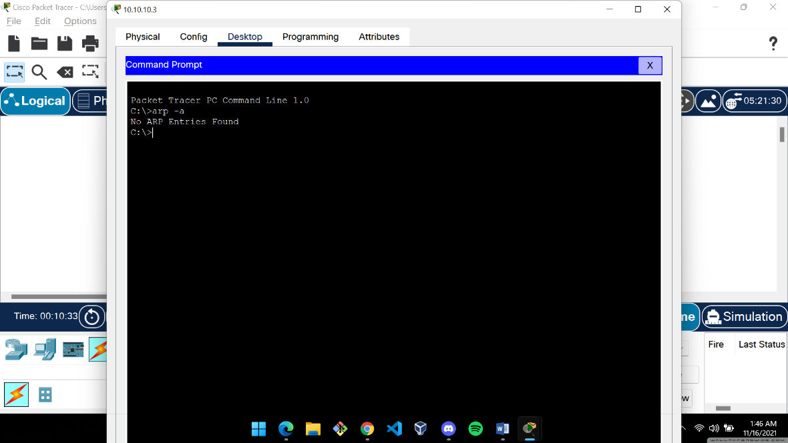

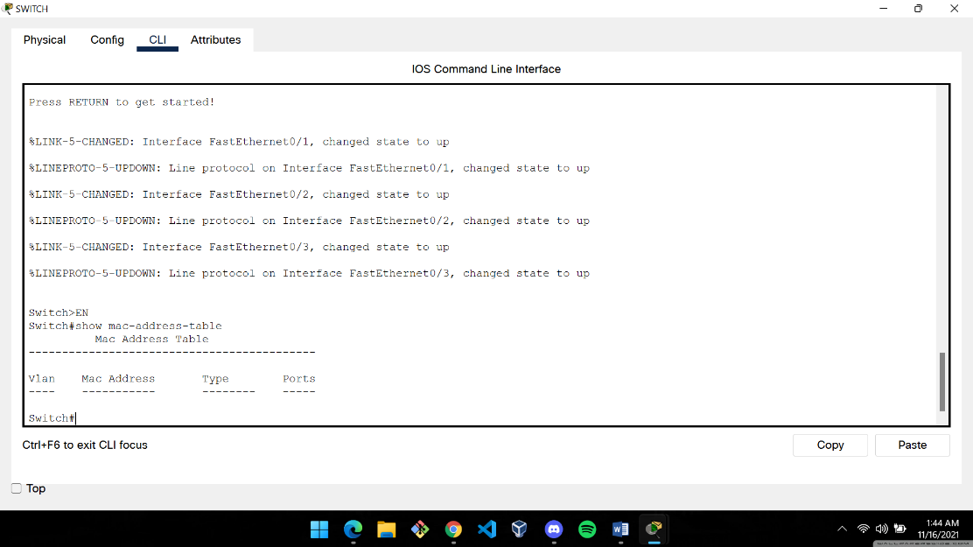

Finally (after pinging each possible pair of nodes):

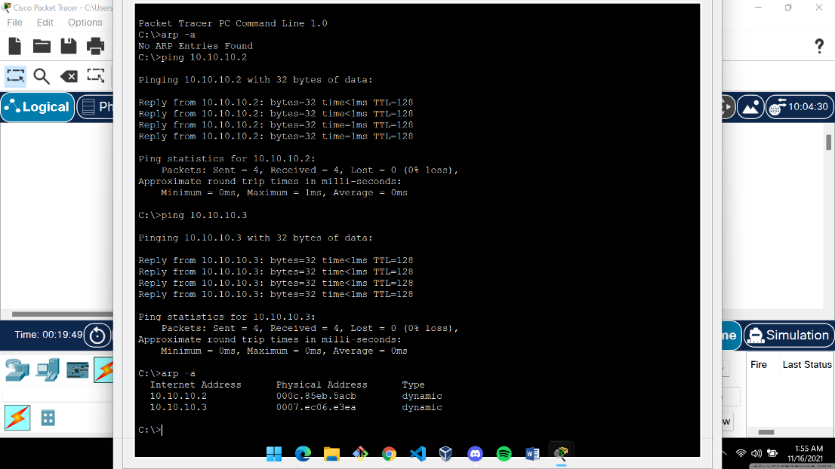 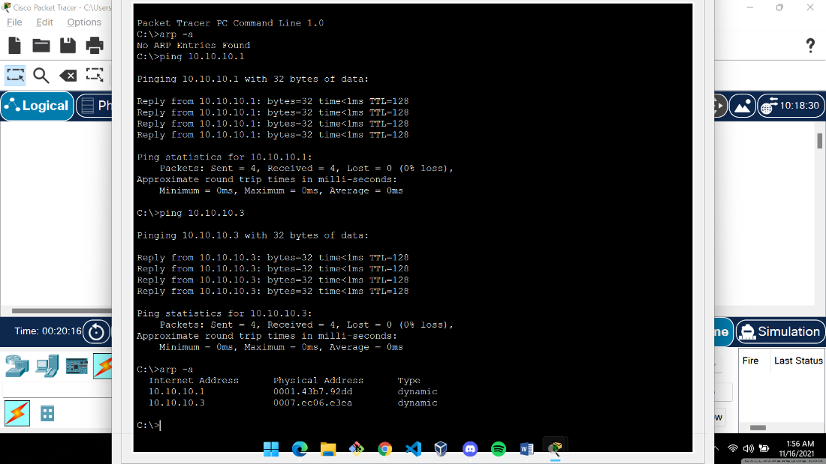

HOST 1 HOST 2

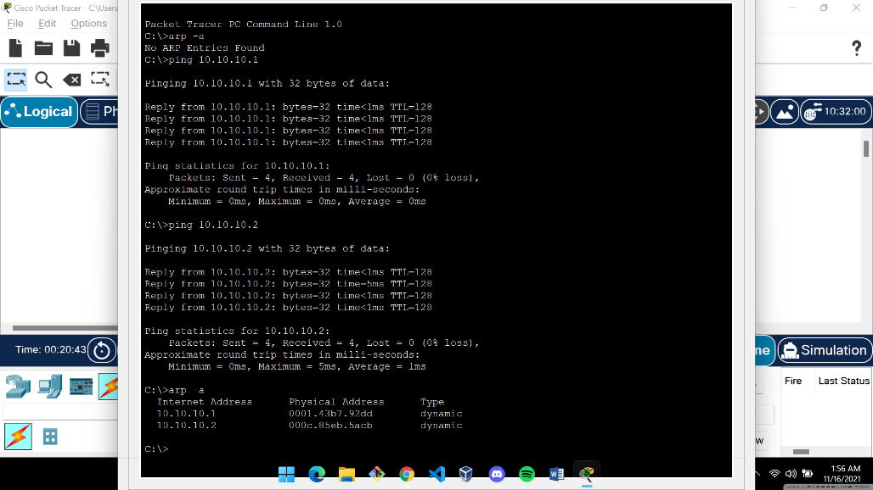

HOST 3

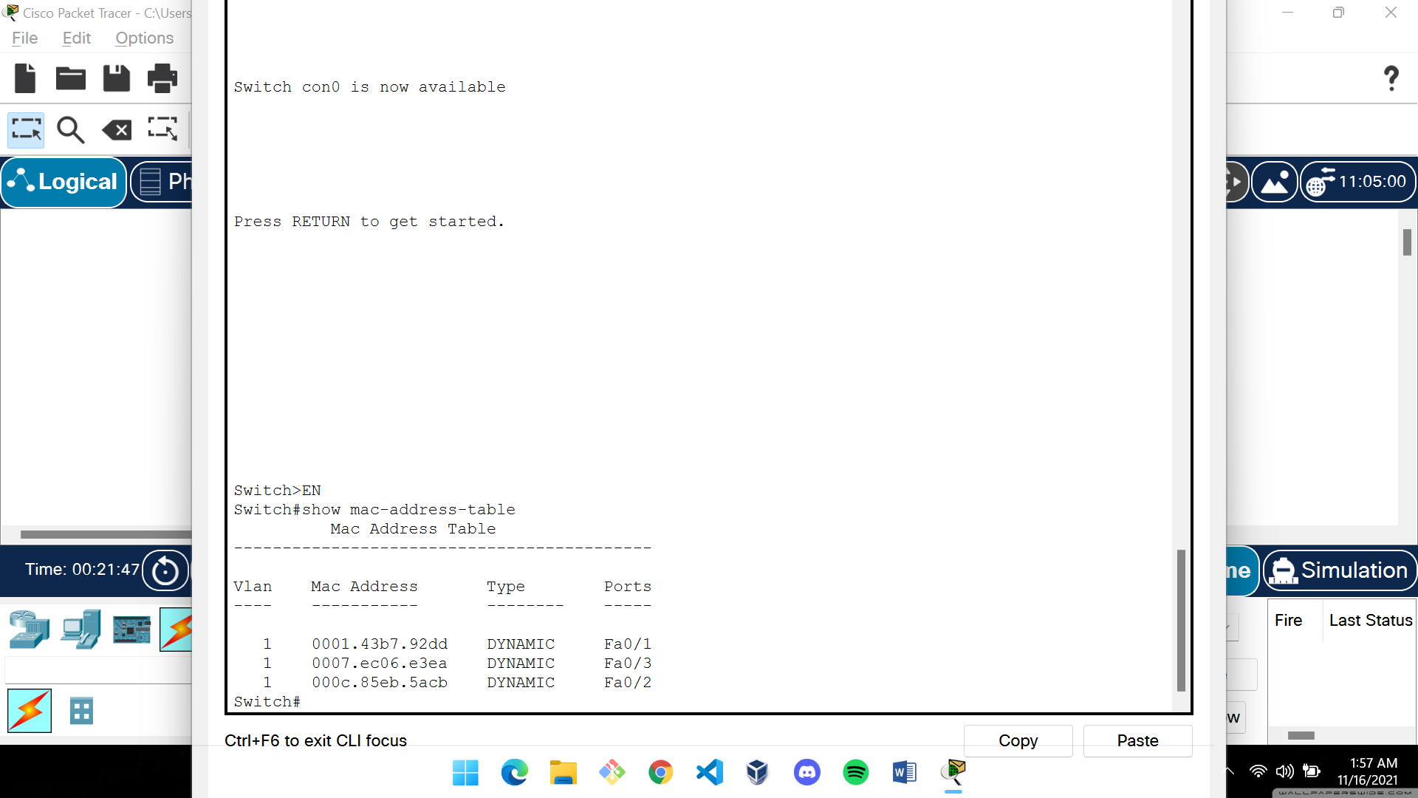

1. **Connect LAN-A and LAN-B by connecting the hub and switch using a cross-over cable. Ping between each pair of hosts of LAN-A and LAN-B. Now record the contents of the ARP Table of end hosts and the MAC Forwarding Table of the switch again.**

LAN-A and LAB-B are connected by using a crossover cable:

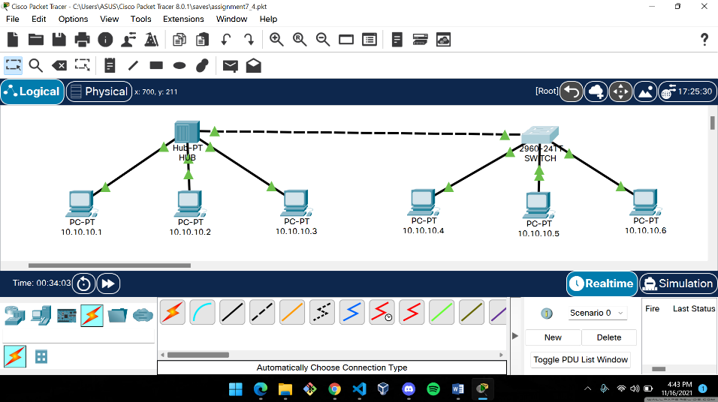

ARP tables of the end hosts of both LAN A and LAN B after establishing connections between all possible pairs of devices:

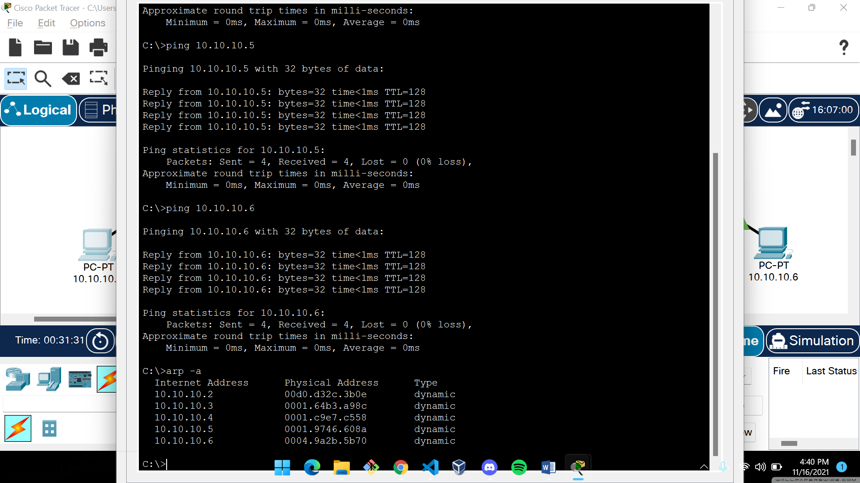 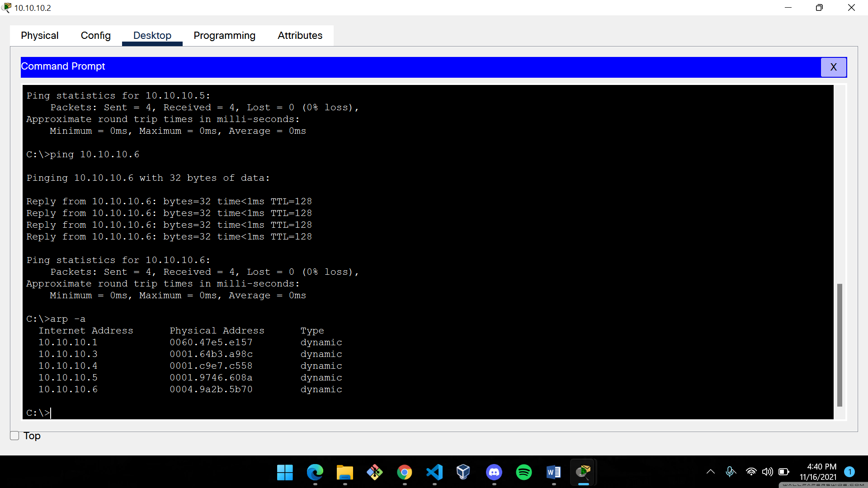

**HOST 1 HOST 2**

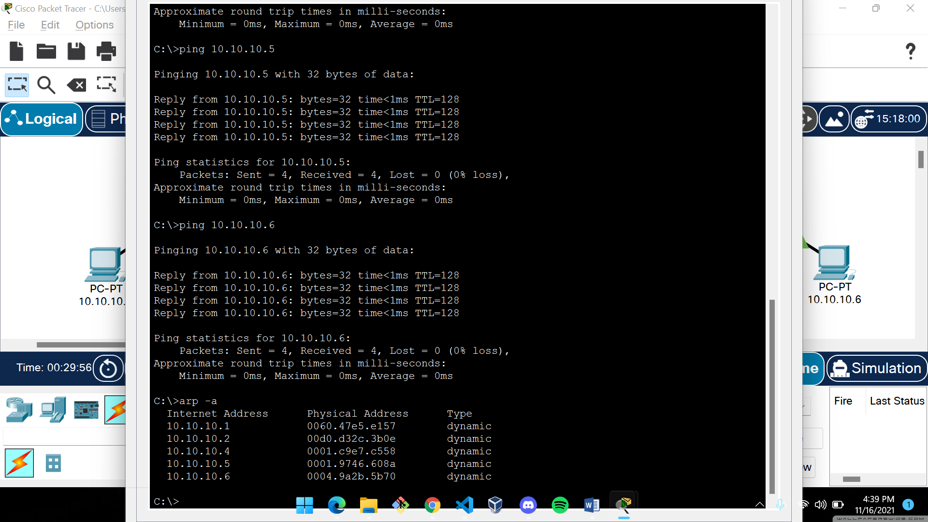 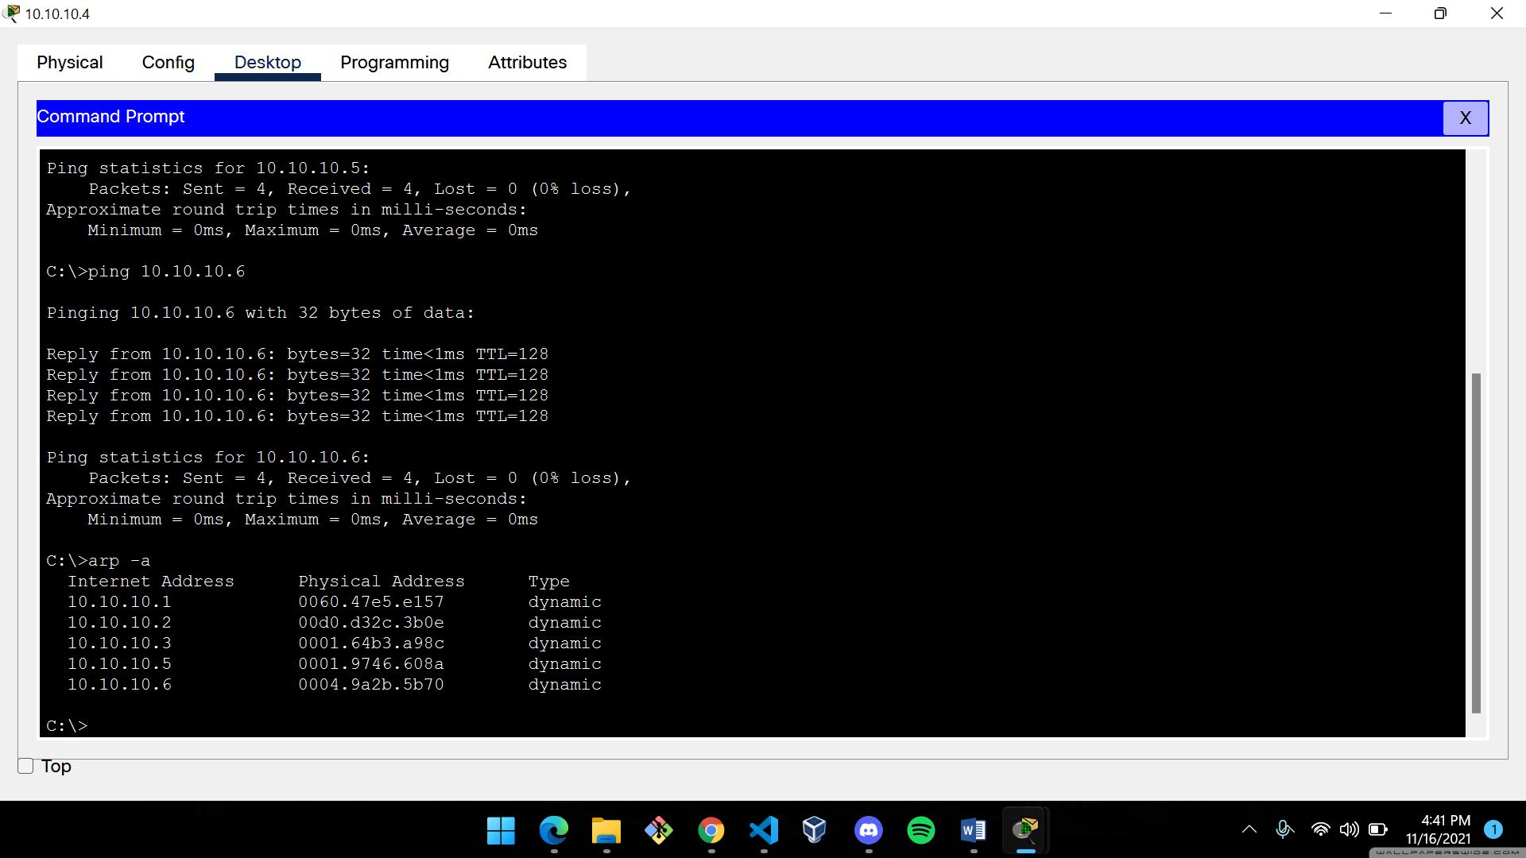

**HOST 3 HOST 4**

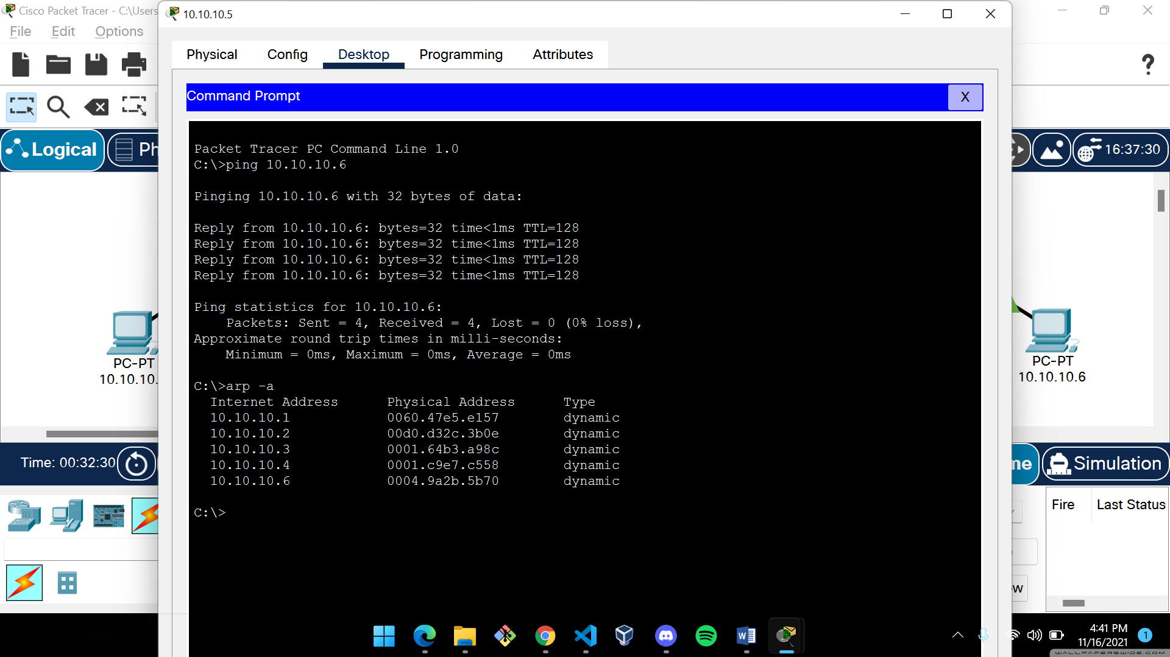 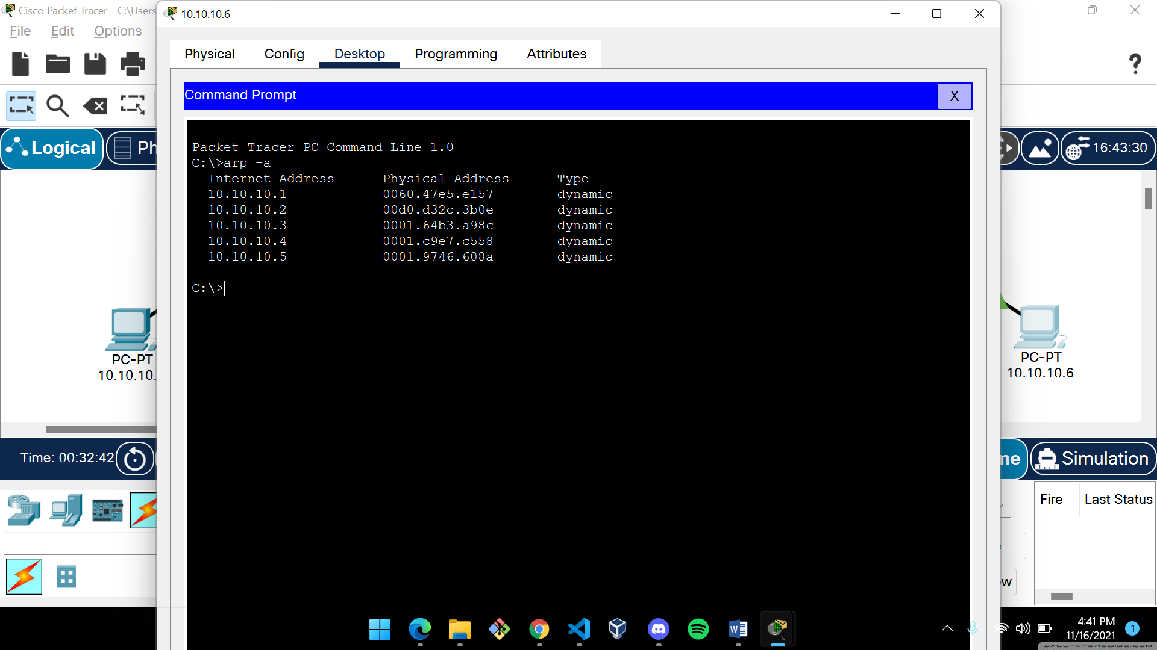

**HOST 5 HOST 6**

MAC Address Table of the switch:

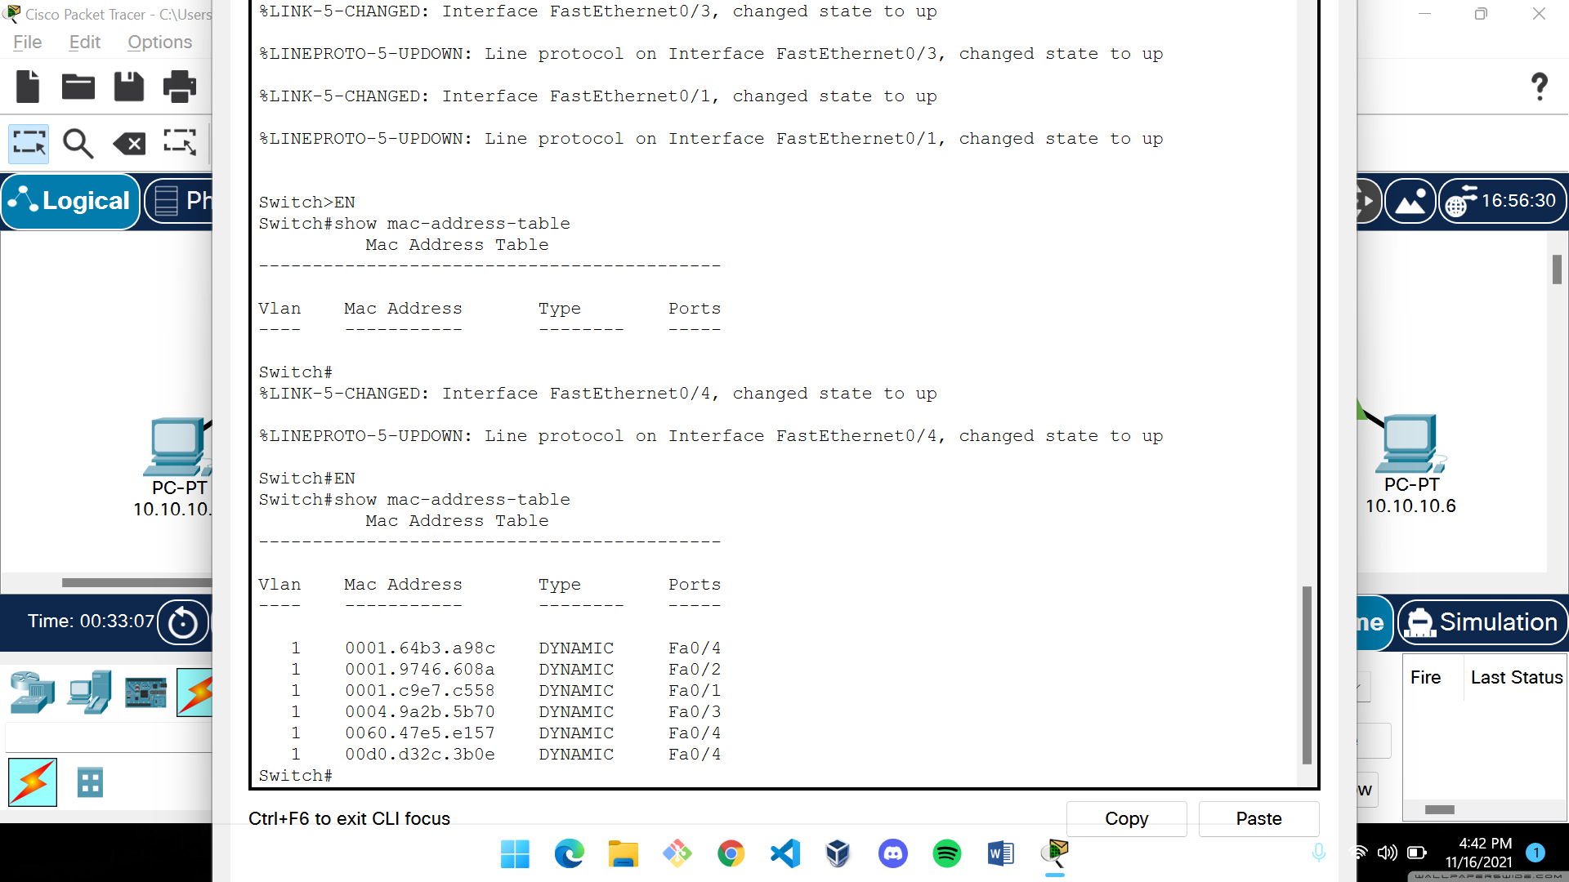

1. **Create a LAN (named JU-Main) with three hosts connected via a layer-2 switch (Cisco 2950 switch PC-LAB1-Switch). Connect the switch to a router (Cisco 1818). Assign IP addresses to all the hosts and the router interface connected to this LAN from network 192.168.148.0/24. Configure default gateway of each hosts as the IP address of the interface of the router which is connected to the LAN. Create another LAN (named JU-SL) with three hosts connected via a layer-2 switch (Cisco 2950 switch PC-LAB2-Switch). Connect this switch to another router (Cisco 1818). Assign IP addresses to all the hosts and the router interface connected to this LAN from network 192.168.149.0/24. Configure default gateway of each hosts as the IP address of the interface of the router which is connected to the LAN. Connect the two routers through appropriate WAN interfaces. Assign IP addresses to the WAN interfaces from network 192.168.150.0/24. Add static route in both of the routers to route packets between two LANs.**

Two separate LANs were created using a switch and three hosts per LAN. Now, both the LANs are connected to one router each. The routers are further connected using a straight through cable.

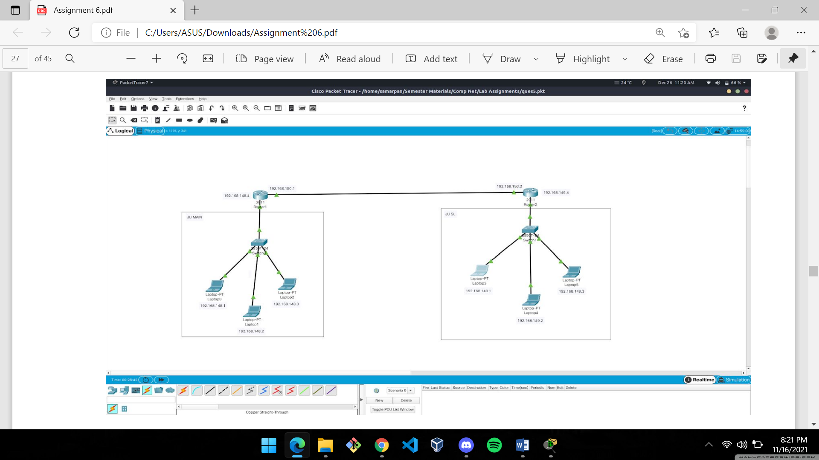

A static route is added between the two routers for communication.

IP ROUTE OF ROUTER 1:

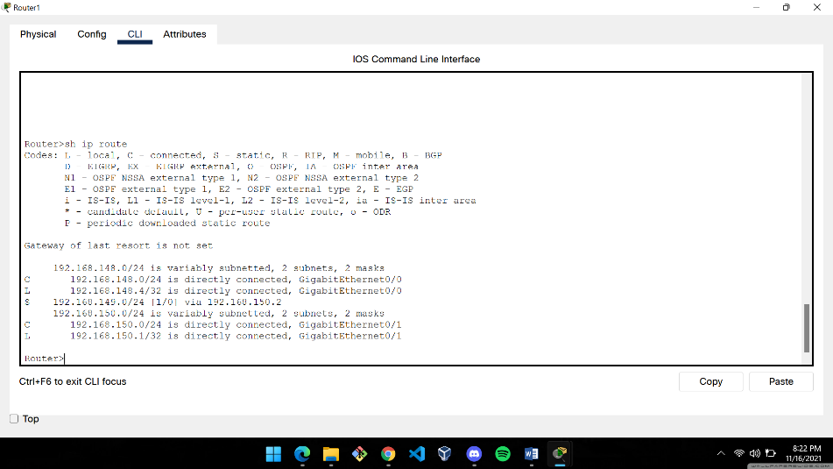

IP ROUTE OF ROUTER 2:

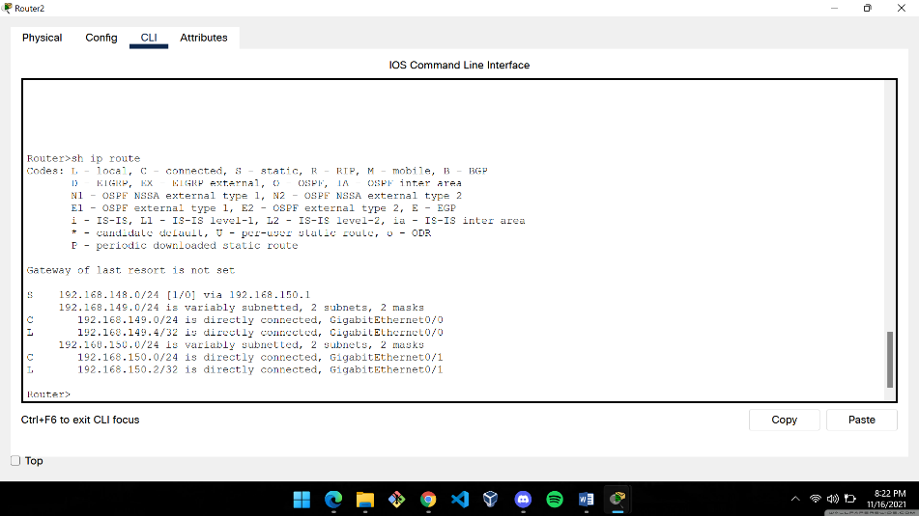

Ping requests were successfully made between the two different LANs.

JU-MAIN TO JU-SL PING

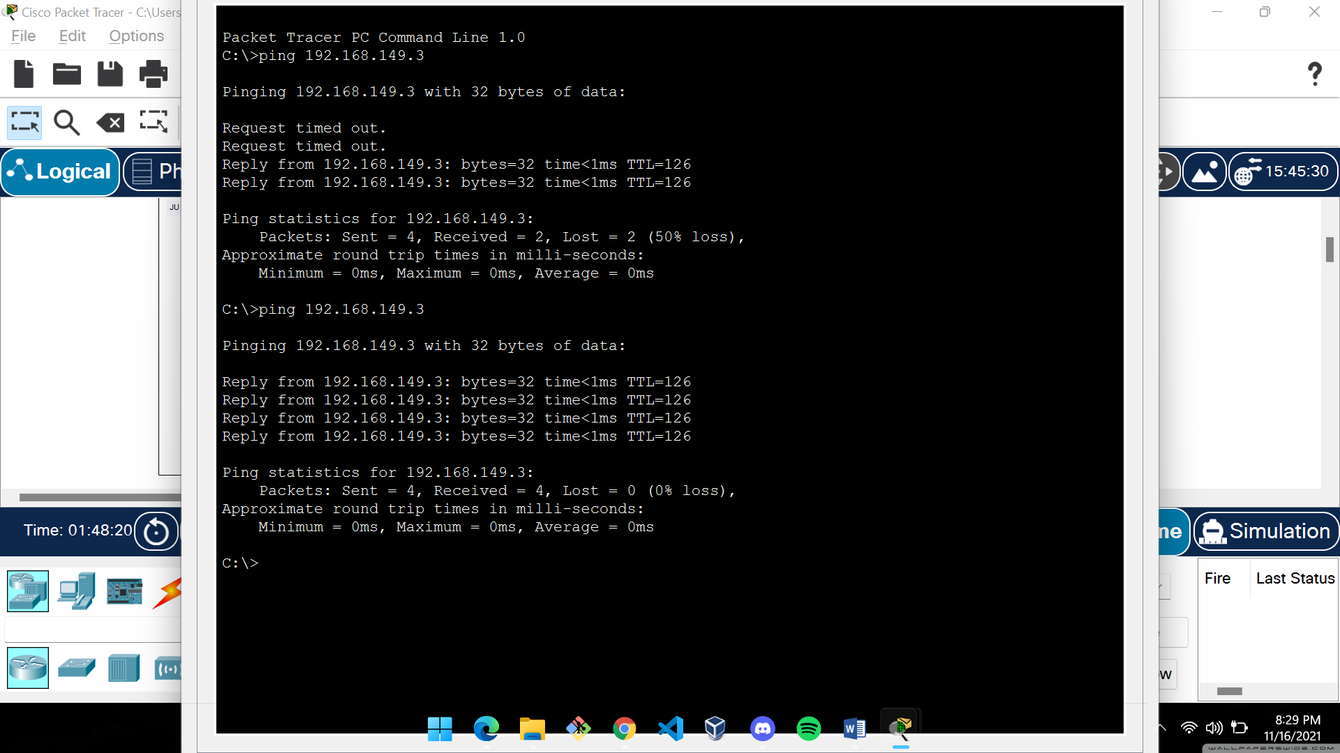

JU-SL TO JU-MAIN PING

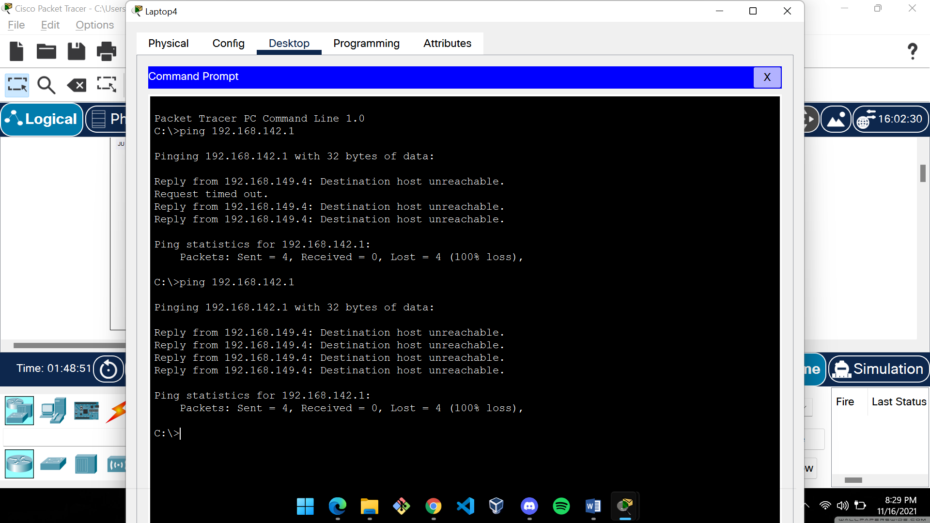

(NB: The initial “request timed out” shows that the router was not yet ready for transmission but eventually the routes became accessible)

1. **Add servers to the individual LANs (in problem 5) and configure them as a DHCP server. Configure the hosts in the individual LAN to obtain IP addresses and address of the default gateway via this DHCP server.**

In each LAN, a server was added and it was configured as a DHCP server. The default gateway was set to the IP of the router of that particular interface.

The IP of the server is set as 192.168.148.5 in JU MAIN and 192.168.149.5 in JU SL.

Now, when new hosts are added, IP address and gateway is provided via the DHCP server.

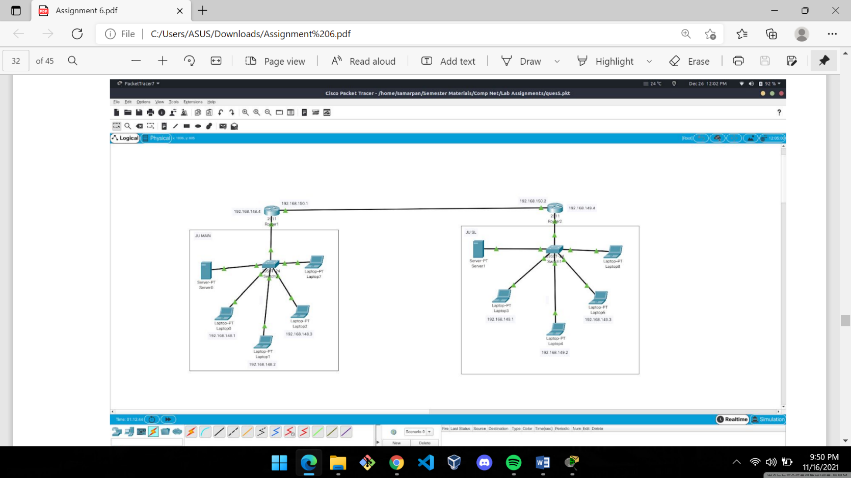

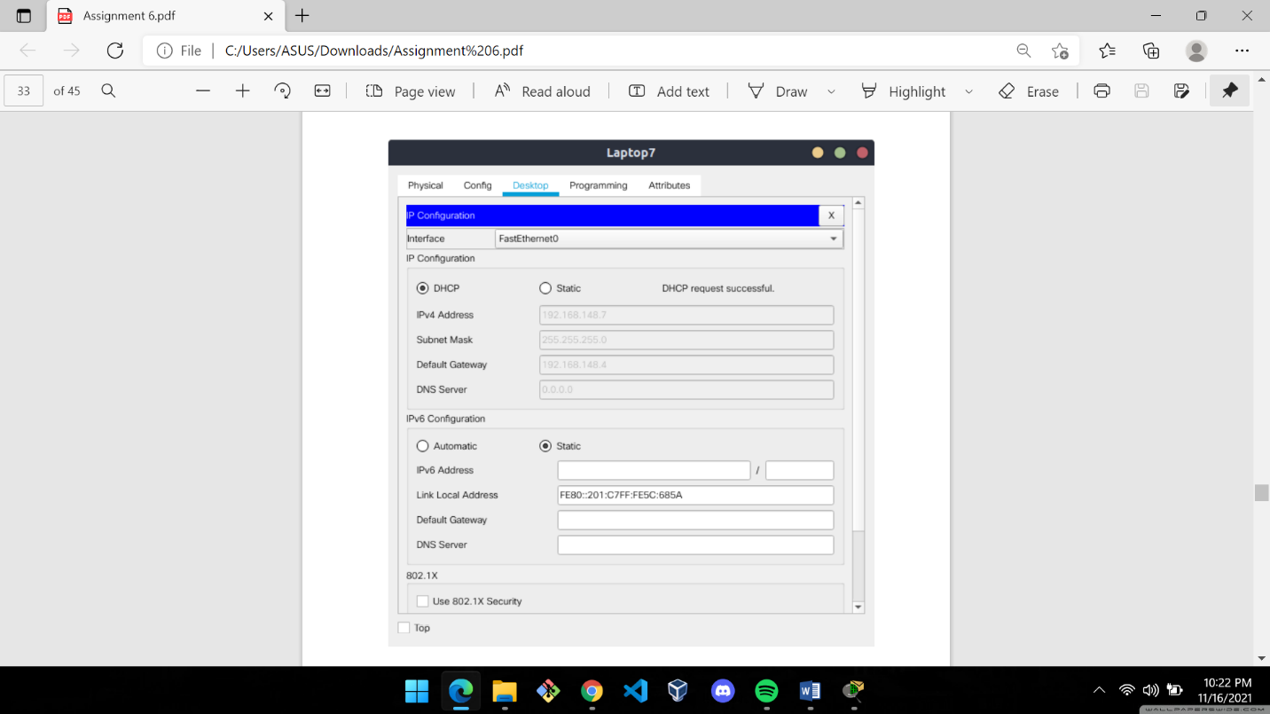

New host is added in JU MAIN:

Assigned IP : 192.168.148.7 Gateway: 192.168.148.4

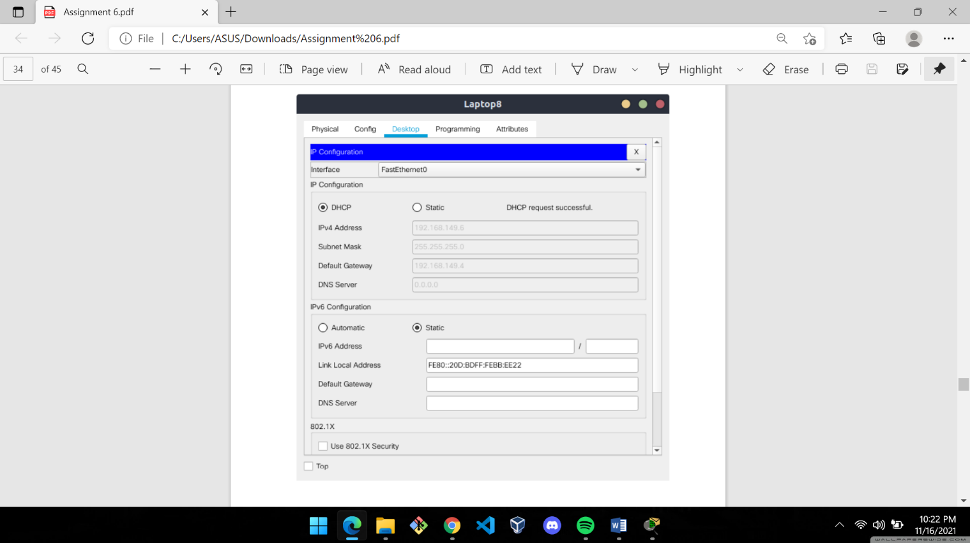

New host is added in JU SL:

Assigned IP : 192.168.149.6 Gateway: 192.168.149.4

PING was successfully executed between new hosts that were created via DHCP server:

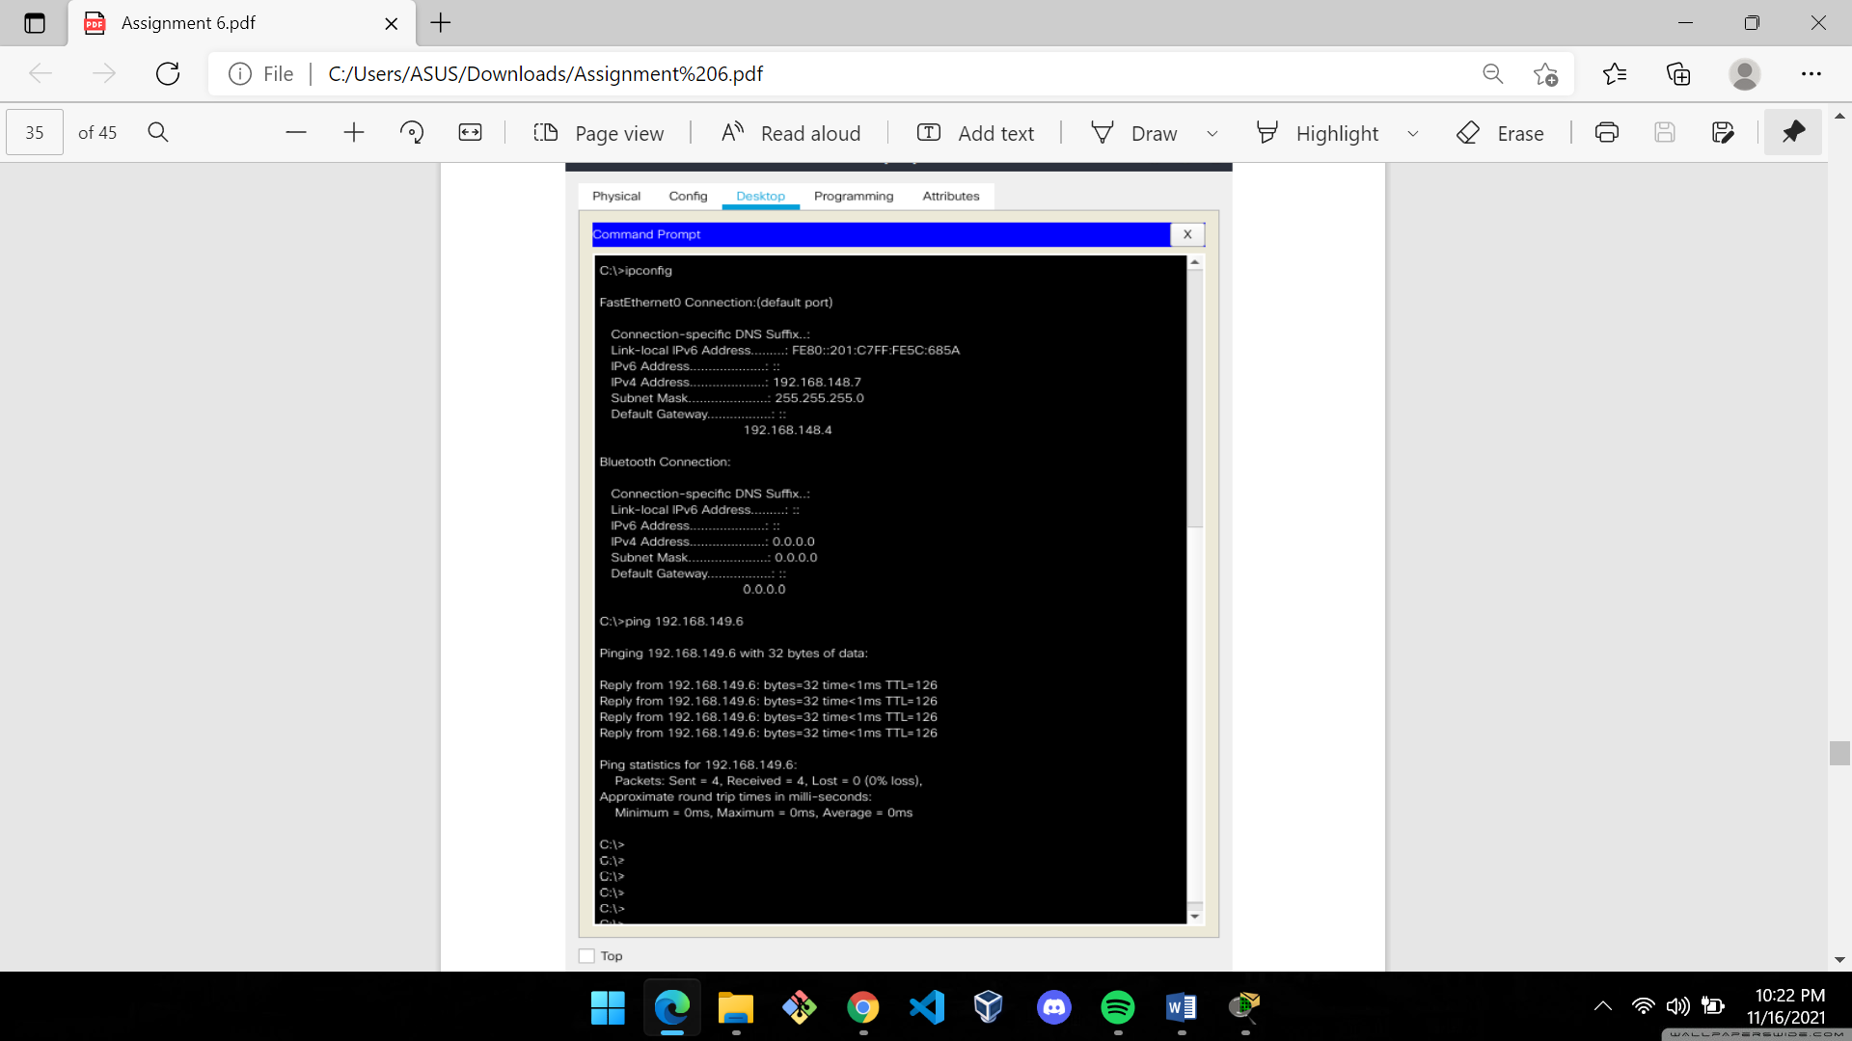 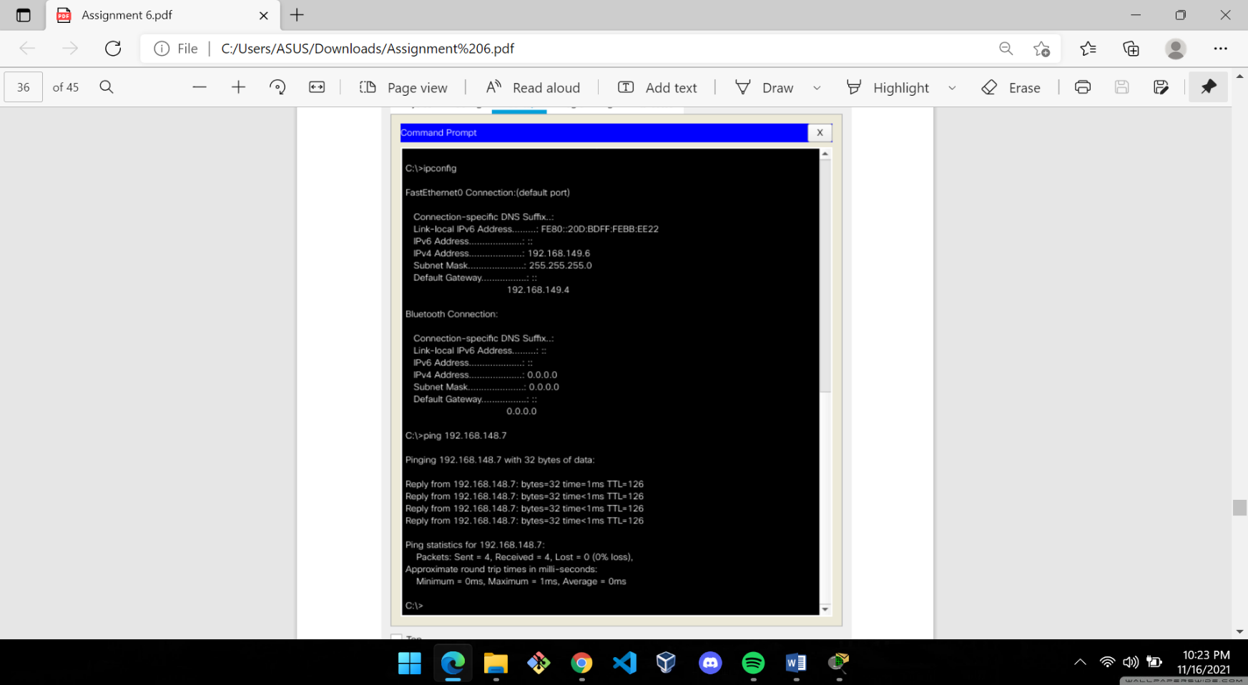

1. **Create a LAN (CSE) with three hosts connected via a layer-2 switch (Cisco 2950 switch CSE-Switch). Also add a web server and a ftp server to this LAN. The hosts dynamically get their IP addresses from a local DHCP server. Servers are assigned fixed IP addresses. Configure the individual hosts to use the local DNS server for name resolution. Add a Domain Name Server (DNS) to this LAN. Create appropriate records in the DNS server for the individual servers in the LAN. The domain name of the LAN is cse.myuniv.edu. Configure the individual hosts to use the local DNS server for name resolution.**

A LAN was created using a switch and three hosts. Four servers were also added to the switch as per the given question. One of them is the DHCP server which was configured so that the hosts added to the switch could generate their own IP address using the DHCP server. A WEB and a FTP server were also added. A DNS server was added and configured. Now, the following were obtained

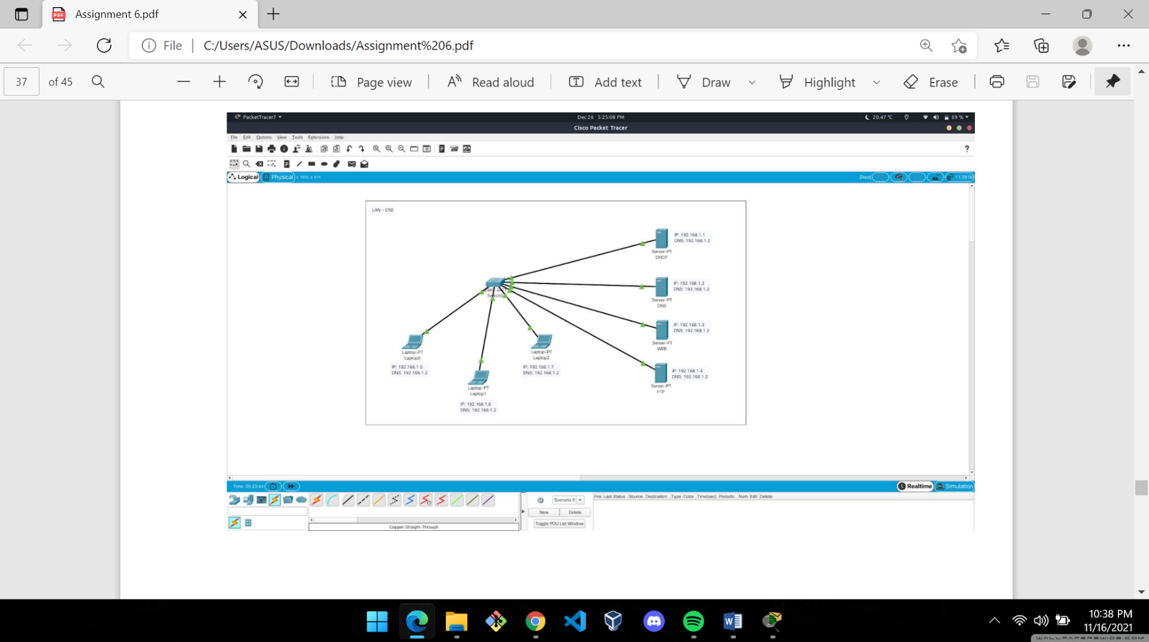

Dynamic IP address generation for a new host:

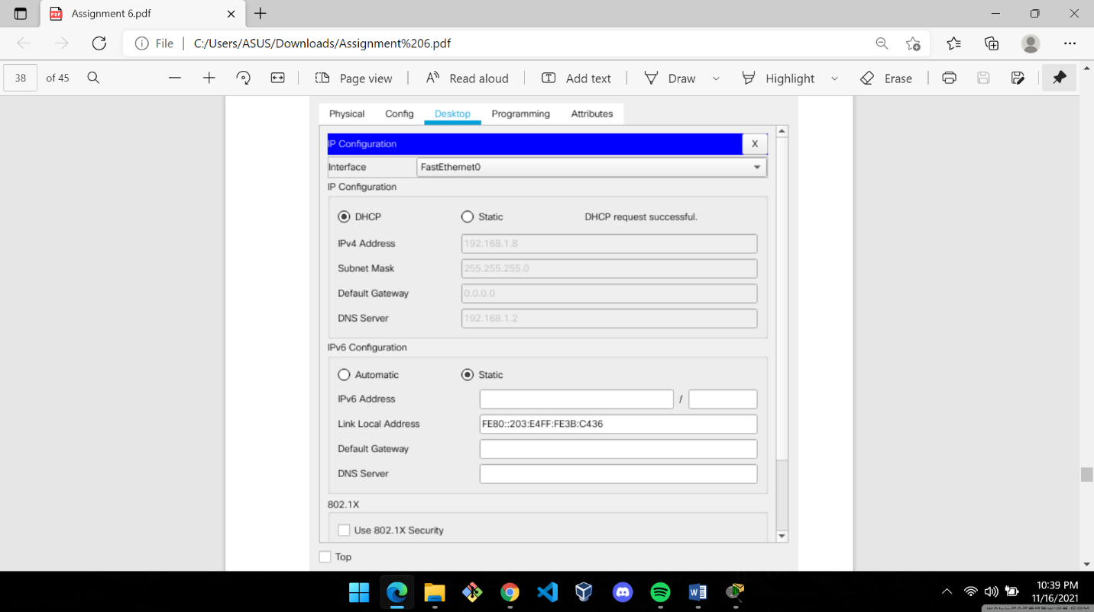

The DNS Record Table:

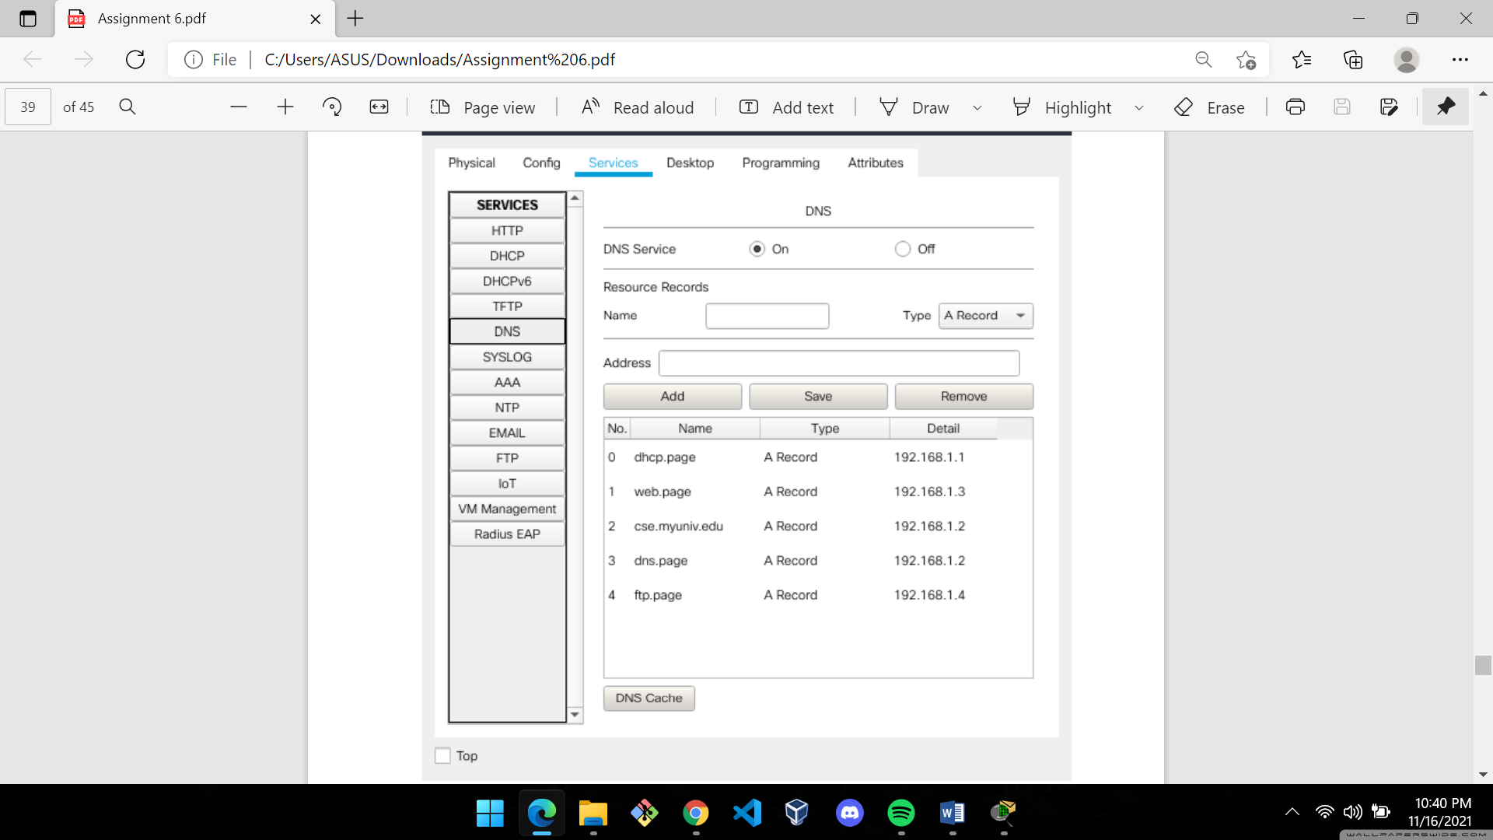

Using the Web Browser in a Host Device connected to LAN:

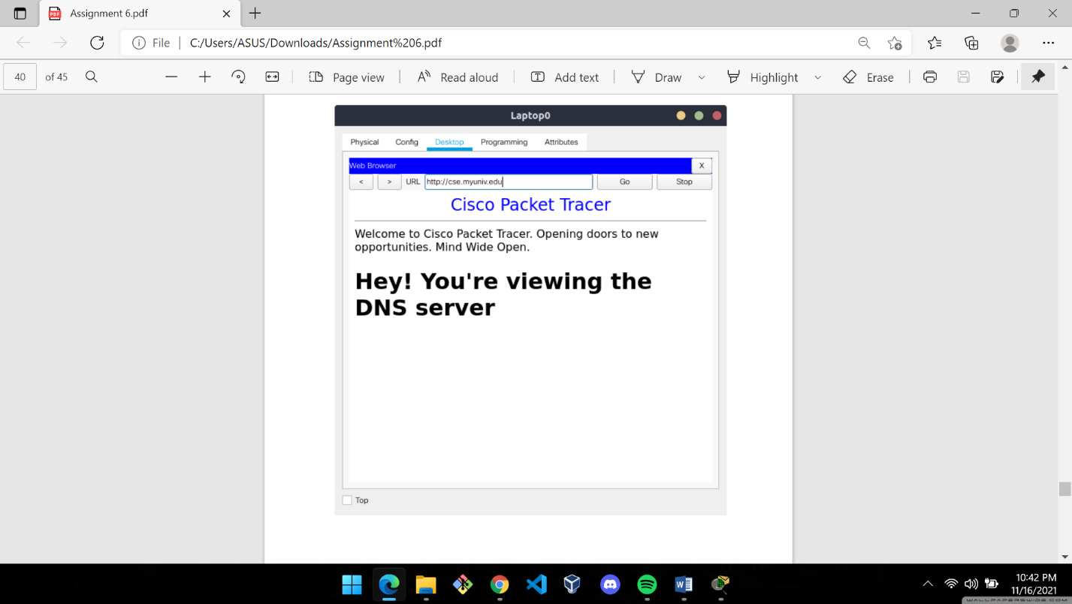 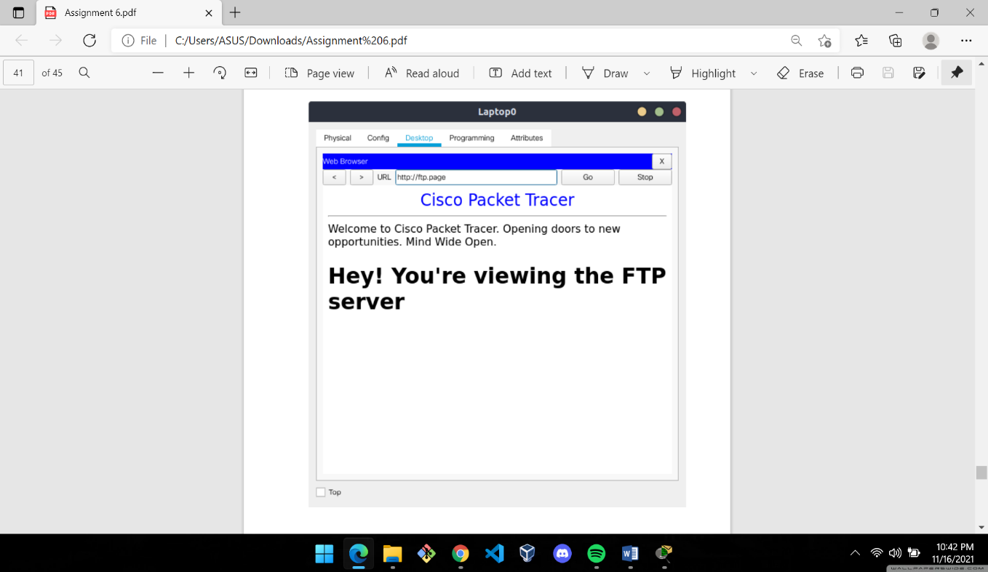

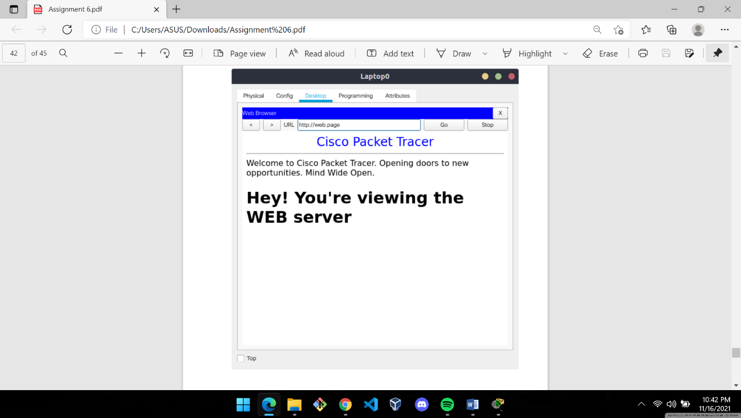 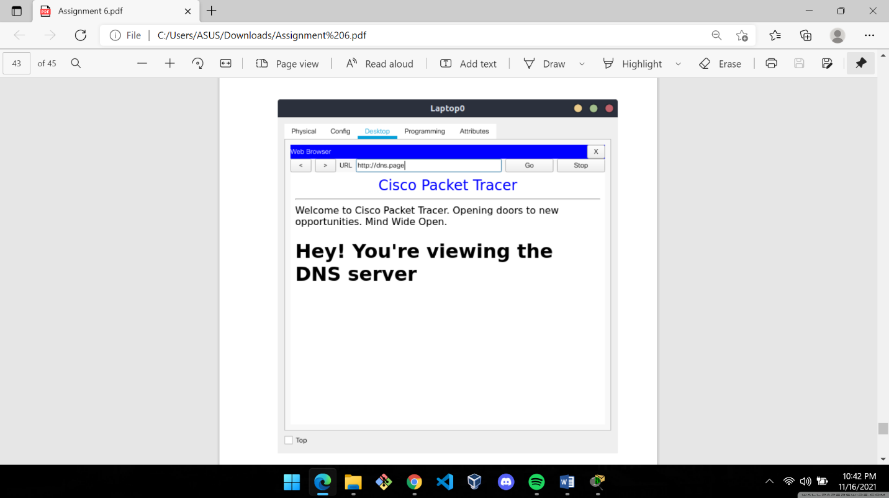

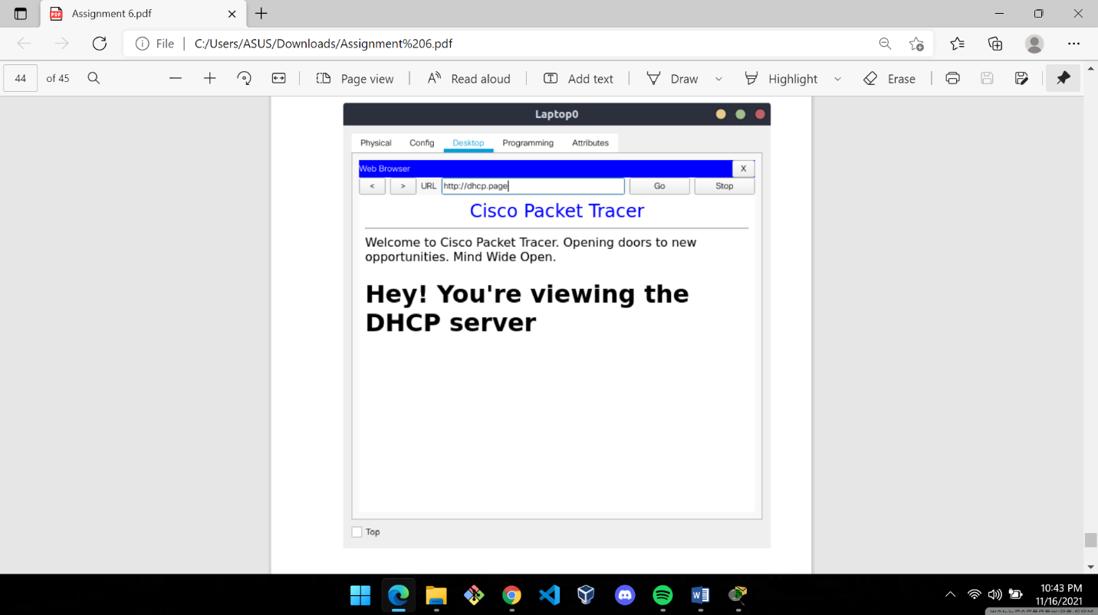

**Comments:**

This assignment gave me an immense opportunity to learn an absolutely new software, Cisco Packet Tracer. I had to explore a lot to perform the experiments and it was really a very exciting experience. Overall, I found this assignment very informative.